Marlon Simon
Educator / Percussionist / Composer
Grants and Awards / Press Quotes

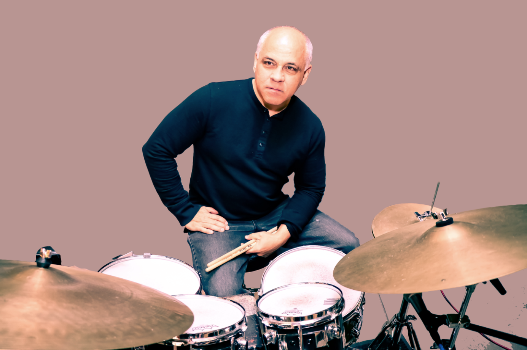
Parallel to his career as a performer, Marlon Simon has also become recognized as an in-demand educator as a specialist in Afro-Caribbean rhythms conducting numerous workshops, master classes and seminars at Temple University, Penn State University, Rutgers University, Haverford college, the New Jersey ABC national Conference for Public School Teachers, the University of the Arts and Perkings Center for the Arts. He has also served as Artist-in-Residence at numerous institutions both in the United States and abroad.
Marlon Simon is the recipient of the following Grants and Awards
- Named Distinguished Teaching Artist in recognition for the decades of dedicated work in music and his history of commitment to preserving and furthering excellence in the Arts and Education, receiving the highest honor among his peers from the New Jersey State Council of the Arts.
- Recipient of the Philadelphia Music Foundation Grant for his outstanding talent and contribution to Philadelphia music scene.
- Received the New Jersey Governor’s Honor Medal Award in Arts and Education.
- Recipient of Chamber Music America Grant to create new works in jazz composition.
- Performed as guest soloist and conducted seminars at The Ultimate Drummers’ Weekend – the largest drumming event in the Southern Hemisphere held in Melbourne, Australia.
- Recipient of the New Jersey Council for the Arts Composition Grant.
- As a special invitee of the US State Department Marlon Simon and The Nagual Spirits were selected to present two international concerts representing the US as an ambassador for excellence in artistry developed in the United States.
- Recipient of the French American Cultural Exchange Grant to conduct Latin Jazz master classes to French musicians, present concerts and record an album.
- Recipient of the Meet the Composer Project Grant to go to Cuba and do research on Afrocuban rhythms and its influence on American Jazz Music.
Press Quotes
"This Latin jazz platter sizzles with Marlon Simon’s percussion. Marlon, who has written a half dozen tunes, creates a set that’s impassioned without being loud."
- Karl Stark, The Philadelphia Inquirer
"Simon is a Venezuelan born percussionist who immigrated to the U.S. bringing with him a fine feel for Latin jazz and a gift for composition."
- Billboard Magazine
"Marlon Simon's fourth CD (In Case You Missed It) with his band The Nagual Spirits provides further proof that the Venezuelan-born, Philly based percussionist is hardly content to rest within the constraints of Latinjazz."
- Shaun Brady, Philadelphia Daily News
"Considered a top scholar and musician in the field of Latin jazz, drummer and percussionist Marlon Simon releases another electrifying album with his band The Nagual Spirits. 'In Case You Missed It' showcases Simon’s rhythmically rich arrangements of four new originals and several standards."
- Edward Blanco, Jazzreview.com

