Marlon Simon
Educator / Percussionist / Composer
Complete Biography
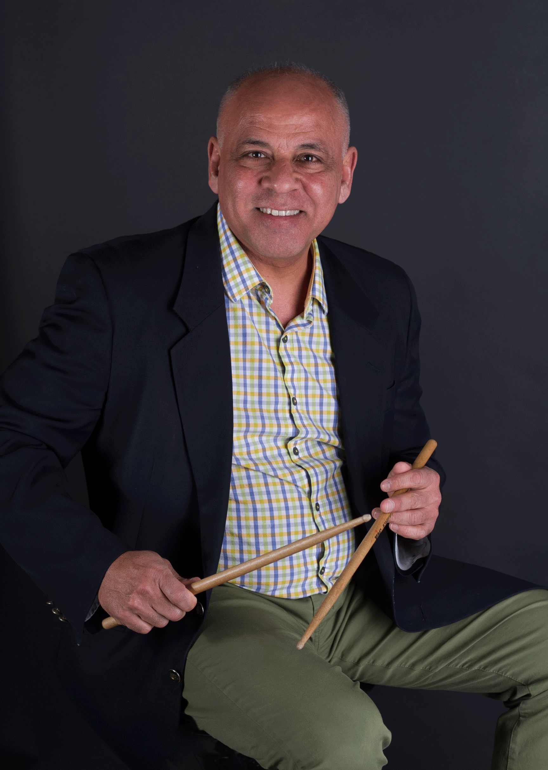
Marlon Simon is the oldest in the latest generation of three musicians bearing the illustrious “Simon” name. The eldest son of Hadsy Simon, a philosopher with a deep understating of the spiritual and the metaphysical realms, and author of the book Consciousness Is All There Is: God Is Consciousness. To the young Marlon, growing up in Punta Cardón, Falcón state, Venezuela, however, Hadsy Simon was more than that. He was “Dad”, of course; as well as a passionate lover of traditional Venezuelan music who played guitar and sang exceedingly well. Marlon recalls vividly how “Whenever we had a visitor my father used to take out his guitar, tune up and herald his guests with his unique interpretations of traditional and popular boleros ( Latin American ballads), Venezuelan waltzes and Christmastime aguinaldos as well. He also used to invite me to join him, playing on a little bongo.”
It was hard not to be seduced by the rhythm of that music and the young Marlon also showed considerable skill in accompanying his father; so much so that Hadsy bought him a pair of timbales when he was just 15 years old. This event set Marlon on a path of discovery; one that would not only challenge him to master his newly acquired instrument but ignite his curiosity about Venezuelan music and the music of all the Americas, which had heard at home and also through like-minded friends. He taught himself most of the rudiments of timbal playing and about all Latin music from salsa, merengue and other South American dance music styles. Within three years, when he was just 18, he felt ready and compelled to perform in public. Turning professional, Marlon put together a band and began to book himself gigs at concerts and local clubs.
A year later, a friend brought him a video which featured Dizzy Gillespie, Chick Corea, Miroslav Vitous and others and his love for Jazz was born. Marlon became seduced by the exciting and eloquent expressions of music that melded elements of African rhythms into concepts that arose out of western-style counterpoint. The magical melodies and harmonic conceptions that Jazz musicians displayed in everything he watched on video and listened to on records, tapes and radio was the final piece in his mental musical puzzle. Such was the lure of this music that Marlon emigrated to the United States in 1987 first to study and later to stay on and make a living in music. But in 1987 he applied for and was accepted into the University of the Arts in Philadelphia. A year later he was awarded the Philadelphia Music Foundation grant. This enabled him to move to New York in 1989 where he enrolled in the New School for Social Research and began working towards a Bachelor of Arts degree in Jazz and Contemporary Music.
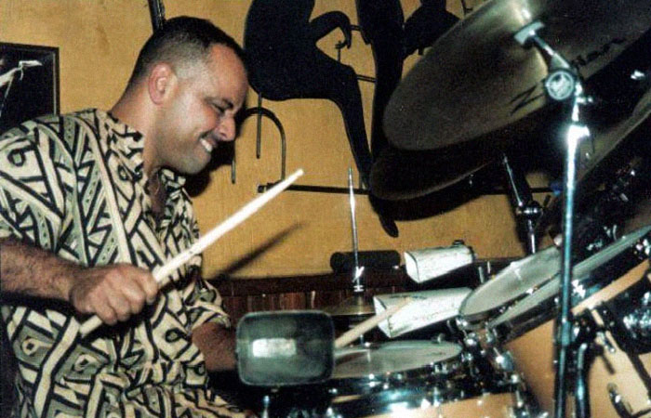
The lure of performance continued to remain strong and quite soon Marlon got busy working as a musician in and around the city bringing his singular Venezuelan-inflected drumming and percussion colourism to the groups that employed him, as well as the many others who simply invited him to sit in after they’d heard his magical music and naturally become entranced by his new voice. This encouraged him to work on finding his voice and building on his highly emotive style that combines the elements of Venezuelan traditional forms, Afro-Caribbean rhythms including clave with the highly improvisatory styles he acquired from listening and mastering the art of syncopation in all its Jazzy glory. Such was the respect accorded to him by some of the great luminaries in Jazz, Latin Jazz and Afro-Caribbean music that he soon became a virtual first-choice rhythmist for Hilton Ruiz, Dave Valentin, Jerry González, Chucho Valdés and Bobby Watson.
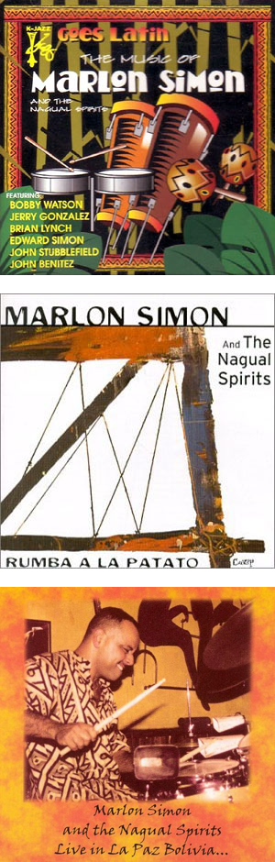
Within a short time this luminous list began to grow exponentially. It was this acceptance and belief in his artistry and vision that compelled Marlon to make the first moves towards forming and leading his own ensemble. Lessons learned from Hadsy Simon and the influences in the realms of the spiritual and metaphysical meant that Marlon’s musical vision was deeply influenced by those elements. It is no wonder then that whatever he did under his own banner – including even the name of his ensemble – had to reflect those influences. He had also read Carlos Castañeda’s iconic books including The Teachings of Don Juan: A Yaqui Way of Knowledge, A Separate Reality: Further Conversations with Don Juan, the Fire From Within and, probably most importantly, Magical Passes: The Practical Wisdom of the Shamans of Ancient Mexico. It seemed natural to bring all of these influences bear in the name of his band: The Nagual Spirits.
“Nagual,” he explains, “Signifies the magical part of the human experience, the spiritual part that cannot be explained by the local thoughts of everyday life,” he says. He began to write more and more music which soon took on a character that was unique so much so that today there is no music that sounds like it anywhere. “Whenever I write, I have to be in a certain state of consciousness – a “nagual” state,” he opines. “It has nothing to do with peyote,” he is quick to add, noting that Castañeda was known for his experiments with peyote while writing his masterpieces, “But I have to get into that side of things. I use meditation to get me closer to that state of being. I wait until a melody gets into my head and begins to live and grow there. I begin to sculpt it and shape it and make it grow until it is ready to be born as a song. Only then do I apply all the theory I learn in college – the chord changes and harmonic theories and conceptions that I was taught. First, however, the music must be born of the mysticism and magic of the “nagual”,” he says.
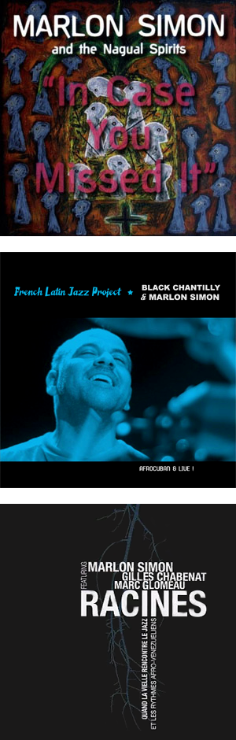
It is just this kind of mysticism, magic and mystery that flavours the recordings that Marlon has made as leader – although his unique voice is heard on many more recordings while working with scores of other artists. His first venture as leader was The Music of Marlon Simon (K-Jazz, 1999); this was followed up with Marlon Simon and The Nagual Spirits Rumba a la Patato (Cubop, 2000). He was joined here by his younger brothers, pianist Edward and trumpeter Michael, along with a constellation of other stars including trumpeter Brian Lynch, tenor saxophonist Peter Brainin and the legendary alto saxophonist and one-time Jazz Messenger, Bobby Watson, pianist Luis Perdomo, bassist Andy González and percussionist Roberto Quintero. While paying homage to the legendary Afro-Cuban, Patato, the recording marked Marlon’s debut as one of the new generation of percussion colourists and held promise for the great things that were to follow. In 2004 Marlon made a recording Live in La Paz, Bolivia (Intrigue Records) which was followed up by another musical adventure, In Case You Missed It (Jazzheads, 2006). His ensemble The Nagual Spirits was bolstered by the presence of trumpeter Alex Norris and, on two tracks, also included a full batá drum contingent with the iconic Cuban Santeria priest Román Díaz and Diego López joining Roberto Quintero to form the trio of batá drummers. Marlon completed a long-felt need to follow his impulses and also write and arrange music that incorporated a string quartet, something that also created a magical soundworld that was mellifluously added to the soundscape that Marlon had already created with the core of The Nagual Spirits.
After spending much time in France, Marlon forged an alliance with several local musicians and produced two critically received recordings. These are: French Latin Jazz Project - Afrocuban & Live (Chantilly Negra Productions, 2008) and Venezuelan French Project (Proyecto Venezolano Francés) - Racines (Raíces) (Chantilly Negra Productions, 2011). The 2008 recording is a prodigious example of excellence in Latin Jazz while the 2011 recording reflects the collision between Venezuelan and French-Celtic-Music. This last recording was perhaps the most ambitious he had attempted up until then. The mystical leaning is evident even as the music attempts to intertwine the roots of Venezuelan music with those of the European (French) tradition that informs the music of his collaborators on that project. It featured an all-French group of musicians and included the inimitable Gilles Chabenat, who brought his hurdy-gurdy (a centuries-old Celtic stringed-instrument that has a magical sound brought about by the winding motion of the crank-shaft that creates a high and lonesome pedal-like sustain).
This last album, Racines (Raíces) is a timely reminder that Marlon Simon and his unique concept of melding the styles of the traditional folkloric styles of Venezuelan music with that of Afro-Caribbean idioms and the African-American Jazz idioms is not only confined to the North and South America. Marlon and The Nagual Spirits have traveled worldwide playing club dates, in concert halls and on the biggest festival stages on both sides of the Atlantic. He has been a worldwide musical ambassador and has visits at the behest of governments from Bolivia to France. His music has also been heard to great appreciation and applause in Canada, Poland, Australia and the Netherland Antilles.
Parallel to his career as a performer, Marlon Simon has also become recognized as an in-demand educator as a specialist in Afro-Caribbean rhythms conducting numerous workshops, master classes and seminars at Temple University, Penn State University, Rutgers University, Haverford college, the New Jersey ABC national Conference for Public School Teachers, the University of the Arts and Perkings Center for the Arts. He has also served as Artist-in-Residence at numerous institutions both in the United States and abroad.

